GUARD  TOUR  SYSTEM

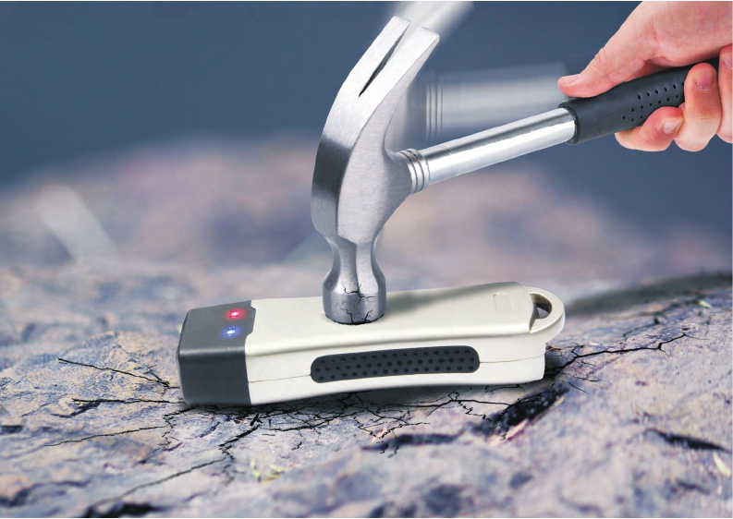

LIGHTING GUARD TOUR SOLUTION

PROFESSIONAL MANUFACTURER SINCE 2006

❶ Sensor area

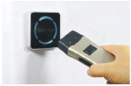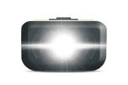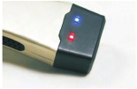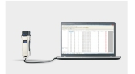

❸ Switch

❺ Torch

❷ LED indicator

❹ Label Area

❻ Anti-slide area

❼ USB port

**Benefits**

**RFID Reading**

Through the 125Khz frequency reading the tag, unnecessary to

direct touching the checkpoint via Equipment.

**Lighting Extension**

A reliable flashlight can save you from any situation where you

need light.

**Impact Records**

Impact record is a timing when employee beating the equipment,

once generated will be permanently stored, administrator can

follow this in apportioning blame.

**USB transmission**

Data can be exported to software with USB cable. No need to

purchase docking station additionally .

**Technical Parameters**

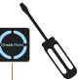

Product name

Lighting mode

Reading technology

Material

Storage

Impact record

Guard Tour/Patrol System

Low, Medium, Strong, strobe and SOS

Read 125kHz EM(ID) tags proximity

Aluminum alloy

80,000 pieces

32,000 pieces

Workable temperature -20 to 70 ℃

Workable humidity 30% to 90%

Communication USB cable

Battery 3.7v built-in rechargeable li-ion battery

Prompt LED +  Vibration

Standard accessories

Data cable, safety protective cover,

charger plug, software

Baud rate 115200 bps

Performance IP 67, waterproof, shockproof

Dimension 130mm x 40mm x25mm

Net weight 170g

**Working Map**

Installation

Analyzing...

Scan

Checkpoint Upload

data

**Content**

Report

Charger

USB cable            Case            Software           Manual